|  |
| --- |
|  |
| Edward River Council  Planning Proposal No 8 |
|  |
|  |
|  |
| **This planning proposal has been prepared to rezone Lots 2, 3 and 4 DP286006 Barham Road from RU1 Primary Production to IN1 General Industrial.** |

**INTRODUCTION**

Council has received a request from the owner of the land to rezone Lots 2, 3 and 4 DP286006 Barham Road from RU1 Primary Production to IN1 General Industrial under the Deniliquin Local Environmental Plan 2013.

**SUBJECT SITE**

The subject site is located on Barham Road and Leetham Road and is held in three titles. The subject site also has frontage to the railway line. The site has a total area of 66.5ha with each lot having the following land area:

|  |  |
| --- | --- |
| **Lot** | **Land Area** |
| Lot 2 DP286006 | 27.25ha |
| Lot 3 DP286006 | 19.49ha |
| Lot 4 DP286006 | 19.75ha |

The site is vacant and used for agriculture ie grazing of livestock. There is no significant vegetation on the site. The site is within the vicinity of the recently approved ethanol plant and Council’s effluent dam. Figure 1 shows the location of the existing site.

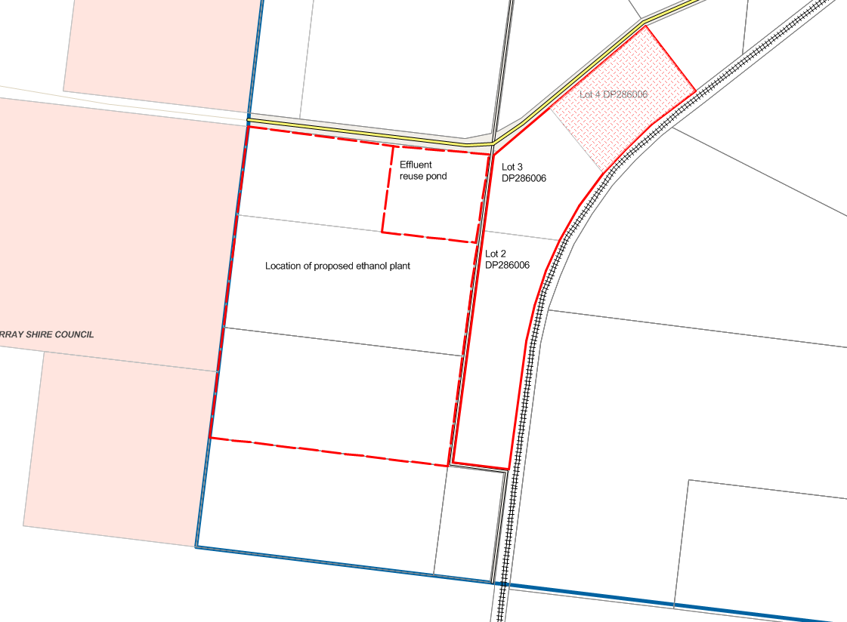

Figure 1 Location of Subject Site

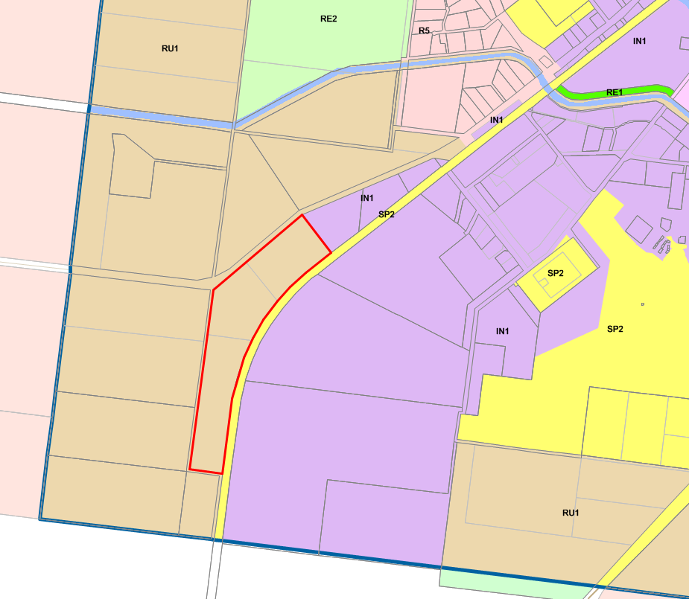

Figure 2 Subject site and surround zones

The site adjoins land zoned IN1 General Industrial, RU1 Primary Production and SP2 Infrastructure (being Barham Road and the railway line). Figure 2 shows the location of the subject site and the adjoining zones.

The land is located adjacent to the existing IN1 General Industrial land and would provide an extension to this zone. The land is in a suitable location as two lots have frontage to Barham Road which is a B-double and road train route. The third lot being Lot 2 DP286006 has frontage to Leetham Road which is a formed gravel road. The land can be serviced with water and sewer and is within the vicinity of land which has recently obtained development consent for the establishment of an ethanol plant. The subject site is surrounded by a mix of agriculture, dwellings, industrial uses and infrastructure (Barham Road and the railway line). Figure 3 is an aerial view of the site and surrounding land.

The rezoning would result in an increase of industrial land availability. Whilst Council has sufficient land zoned for industrial uses, Council does not have large lots available where there is direct access to B double and road train routes and services are available within the vicinity of the land. Existing land supply is not market ready due to a lack of services, inadequate road access, size of lots and land bankers.

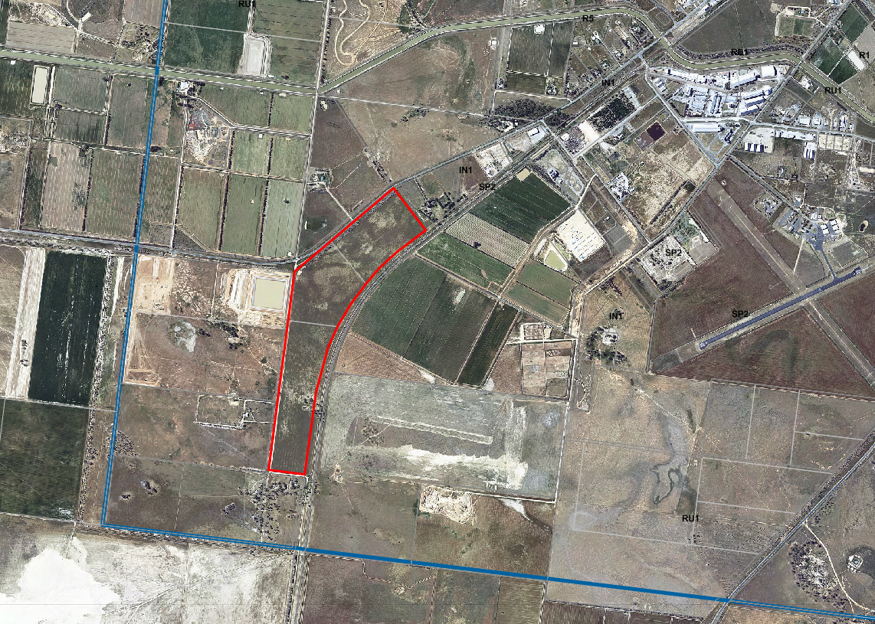

Figure 3 Aerial view of subject site and surrounding land uses

**PART 1 OBJECTIVES OR INTENDED OUTCOMES**

The objective of this planning proposal is to rezone Lots 2, 3 and 4 DP286006 Barham Road from RU1 Primary Production to IN1 General Industrial under the Deniliquin Local Environmental Plan 2013 (LEP2013).

**PART 2 EXPLANATION OF PROVISIONS**

The proposed outcome will be achieved by amending Land Zoning Map – Sheet LZN_003 to show the subject site (identified in Figure 1) as being zoned IN1 General Industrial. Lot Size Map LSZ_003 would be amended by removing the minimum lot size provisions that currently apply to the site. There are no minimum lot size provisions under LEP 2013 for the IN1 General Industrial zone.

**PART 3 JUSTIFICATION**

*Is the planning proposal a result of any strategic study or report?*

The planning proposal is not the result of any strategic study or report. The planning proposal is the result of a request from a land owner. Council is considering a local strategy for the newly formed Edward River Council prior to the consolidation of the 3 LEPs applying to the former Deniliquin and Conargo Shire Councils.

*Is the planning proposal the best means of achieving the objectives or intended outcomes, or is there a better way?*

The planning proposal is the most appropriate means of achieving the objectives and intended outcomes as it will allow for the rezoning and the amendment of the minimum lot size provisions applying to this site. The location of the site on a regional road with approved heavy vehicle use means that the land is ideally located for the extension of the industrial zone in this location.

Council does have land that is currently zoned industrial but due to its location remains vacant. Council believes the reason for this is its location on roads which are either not sealed or adequately formed for access by heavy vehicles and the lack of other infrastructure ie water and sewer. The value of the land versus the cost of servicing the land means that it is not viable to develop this land currently zoned industrial.

*Is the planning proposal consistent with the objectives and actions of the applicable regional or sub-regional strategy?*

There is no regional or sub-regional strategy for the Edward River Local Government area.

*Is the planning proposal consistent with a council local strategy or other local strategic plan?*

Edward River Council does not have a local strategy or other local strategic plan that applies to the former Deniliquin Local Government Area. Council is considering a local strategy for the newly formed Edward River Council prior to the consolidation of the 3 LEPs applying to the former Deniliquin and Conargo Shire Councils.

*Is the planning proposal consistent with the applicable State Environmental Planning Policies?*

The planning proposal is consistent with SEPPs. SEPPs have been considered in Appendix 1.

*Is the planning proposal consistent with applicable Ministerial Directions (s117 directions)?*

Section 117 Directions have been considered in Appendix 2. Where the planning proposal is inconsistent with a Direction the inconsistency is of minor significance.

*Is there any likelihood that critical habitat or threatened species, populations or ecological communities, or their habitats, will be adversely affected as a result of the proposal?*

No.

*Are there any other likely environmental effects as a result of the planning proposal and how are they proposed to be managed?*

It is considered that no adverse environmental impacts are likely to arise as a result of the planning proposal.

*Has the planning proposal adequately addressed any social and economic effects?*

The planning proposal would not result in any adverse social and economic impacts. Increasing the availability of industrial land with access to a regional road that permits heavy vehicle movements will be an economic opportunity for industrial development in Deniliquin.

*Is there adequate public infrastructure for the planning proposal?*

Two of the lots have frontage Barham Road which is a regional road and permits heavy vehicles. There is no water or sewer servicing the site but the services could be extended to the site. Lot 2 DP286006 only has frontage to Leetham Road which is a formed gravel road.

Clause 6.7 of LEP 2013 does not allow Council to grant consent for development unless it is satisfied that certain services that are essential for the development are available or adequate arrangements have been made to make them available. This clause would allow Council to address infrastructure needs at the development application stage.

*What are the views of state and Commonwealth public authorities consulted in accordance with the Gateway determination?*

At this stage a gateway determination has not been issued. Council will consult with relevant State and Commonwealth authorities if required to do so when the gateway determination has been issued.

**PART 4 MAPPING**

The following LEP 2013 would be required to be amended:

* Land Zoning Map – Sheet LZN_003 to show the subject site (identified in Figure 1) as being zoned IN1General Industrial.
* Lot Size Map LSZ_003 would be amended by removing the minimum lot size provisions that currently apply to the site. There are no minimum lot size provisions under LEP 2013 for the IN1 General Industrial zone.

**PART 5 COMMUNITY CONSULTATION**

In accordance with section 57 of the Environmental Planning and Assessment Act, it is proposed to exhibit the planning proposal for 14 days in the local media and on Council’s website. Adjoining land owners would be notified.

**PART 6 PROJECT TIMELINE**

Given the nature of the amendment, Council proposes to complete the amendment in 6 months.

**APPENDIX 1**

**STATE ENVIRONMENTAL PLANNING POLICIES**

|  |  |  |
| --- | --- | --- |
| **SEPPs** | **Consistent** | **Comments** |
| SEPP 21 Caravan Parks | N/A | The planning proposal does not include any provisions relevant to this SEPP. |
| SEPP 30 Intensive Agriculture | N/A | The planning proposal does not include any provisions relevant to this SEPP. |
| SEPP 33 Hazardous and Offensive Development | N/A | The planning proposal does not include any provisions relevant to this SEPP. |
| SEPP 36 Manufactured Home Estates | N/A | The planning proposal does not include any provisions relevant to this SEPP. |
| SEPP 50 Canal Estate Development | N/A | The planning proposal does not include any provisions relevant to this SEPP. |
| SEPP 52 Farm Dams and Other Works in Land and Water Management Plan Areas | N/A | The planning proposal does not include any provisions relevant to this SEPP. |
| SEPP 55 Remediation of Land | Yes | The land is currently vacant and has been used for grazing. The proposed rezoning is not proposing a more ‘sensitive’ land use eg residential. Therefore it is considered that no further consideration of this SEPP is required. |
| SEPP 62 Sustainable Aquaculture | N/A | The planning proposal does not include any provisions relevant to this SEPP. |
| SEPP 64 Advertising and Signage | N/A | The planning proposal does not include any provisions relevant to this SEPP. |
| SEPP 65 Design Quality of Residential Flat Development | N/A | The planning proposal does not include any provisions relevant to this SEPP. |
| SEPP (Affordable Rental Housing) 2009 | N/A | The planning proposal does not include any provisions relevant to this SEPP. |
| SEPP (Building Sustainability Index: BASIX) 2004 | N/A | The planning proposal does not include any provisions relevant to this SEPP. |
| SEPP (Exempt and Complying Development Codes) 2008 | N/A | The planning proposal does not include any provisions relevant to this SEPP. |
| SEPP (Housing for Seniors or People with a Disability) 2004 | N/A | The planning proposal does not include any provisions relevant to this SEPP. |
| SEPP (Infrastructure) 2007 | N/A | The planning proposal does not include any provisions relevant to this SEPP. |
| SEPP (Integration and Repeals) 2016 | N/A | The planning proposal does not include any provisions relevant to this SEPP. |
| SEPP (Mining, Petroleum Production and Extractive Industries) 2007 | N/A | The planning proposal does not include any provisions relevant to this SEPP. |
| SEPP (Miscellaneous Consent Provisions) 2007 | N/A | The planning proposal does not include any provisions relevant to this SEPP. |
| SEPP (Rural Lands) 2008 | N/A | The planning proposal does not include any provisions relevant to this SEPP. |
| SEPP (State and Regional Development) 2011 | N/A | The planning proposal does not include any provisions relevant to this SEPP. |

**APPENDIX 2**

**SECTION 117 DIRECTIONS**

|  |  |  |
| --- | --- | --- |
| **Section 117 Direction** | **Consistent** | **Comments** |
| 1.1 Business and Industrial Zones | Yes | This direction applies to this planning proposal as it is proposed to zone the land IN1 General Industrial and it is considered that it is consistent with this direction.  The land is located adjacent to the existing IN1 General Industrial land and would provide an extension to this zone. The land is in a suitable location as it has frontage to Barham Road which is a B-double and road train route. The land can be serviced with water and sewer and is within the vicinity of land which has recently obtained development consent for the establishment of an ethanol plant.  The rezoning would result in an increase of industrial land availability. Whilst Council has sufficient land available for industrial uses, Council does not have large lots available where there is direct access to B double and road train routes and services are available within the vicinity of the land. Existing land supply is not market ready due to a lack of services, adequate road access, adequate land area and land bankers. |
| 1.2 Rural Zones | No | This direction applies to this planning proposal as it is proposed to rezone the land from rural to industrial. The planning proposal is inconsistent with this direction as Council does not have a strategy to support the planning proposal. However, the inconsistency is of a minor nature given that the rezoning involves 66.49ha of rural land which in the context of rural land within the Edward River Council area is not significant. The rezoning of this land will increase the availability of industrial land in a desirable location. |
| 1.3 Mining, Petroleum Production and Extractive Industries | Yes | The planning proposal will not prohibit the mining of coal or other minerals, production of petroleum or winning or obtaining of extractive materials or restrict the potential development of resources of coal, other minerals, petroleum or extractive materials which are of State or regional significance by permitting a land use that is likely to be incompatible with such development. |
| 1.4 Oyster Aquaculture | N/A |  |
| 1.5 Rural Lands | No | This direction applies to this planning proposal but is inconsistent with this direction as it proposes to rezone RU1 land to IN1. Clause 4(a) of the direction requires a planning proposal to be consistent with the Rural Planning Principles listed in SEPP (Rural Lands) 2008. The inconsistency with this direction is of minor significance when considering the following Rural Planning Principles:  a *The promotion and protection of opportunities for current and potential productive and sustainable economic activities in rural areas* – There is a significant amount of land zoned for agricultural pursuits within the LGA. The reduction in land zoned for rural pursuits will not significantly impact opportunities for economic activities in rural areas.  b *Recognition of the importance of rural lands and agriculture and the changing nature of agriculture and of trends, demands and issues in agriculture in the area, region or State* – Council is aware of the importance of rural lands to the economy and the rezoning of this land will not result in a significant reduction in rural land available for rural pursuits.  c Recognition of the significance of rural land uses to the State and rural communities, including the social and economic benefits of rural land use and development - *Council is aware of the importance of rural lands to the economy and the rezoning of this land will not result in a significant reduction in rural land available for rural pursuits*.  d In planning for rural lands, to balance the social, economic and environmental interests of the community – The rezoning will not result in a significant loss of rural land for this local government area. However, the provision of industrial land within this location allows for a logical extension to the industrial area where there is direct access to a regional road with approval for heavy vehicle movements and within the vicinity of infrastructure.  e The identification and protection of natural resources, having regard to maintaining biodiversity, the protection of native vegetation, the importance of water resources and avoiding constrained land – The subject site consists of three paddocks and no constraints have been identified for the land.  f *The provision of opportunities for rural lifestyle, settlement and housing that contribute to the social and economic welfare of rural communities* – Council has adequate land available for provide for a rural lifestyle, settlement and housing. The rezoning of this land will not significantly reduce these opportunities.  g *The consideration of impacts on services and infrastructure and appropriate location when providing for rural housing* – This planning proposal does not provide for rural housing.  h *Ensuring consistency with applicable regional strategy of the Department of Planning or any applicable local strategy endorsed by the Director-General* – N/A |
| 2.1 Environment Protection Zones | n/a | - |
| 2.2 Coastal Protection | n/a | - |
| 2.3 Heritage Conservation | n/a | - |
| 2.4 Recreation Vehicle Areas | n/a | - |
| 2.5 Application of E2 and E3 Zones and Environmental Overlays in Far North Coast LEPs | n/a | - |
| 3.1 Residential Zones | n/a | - |
| 3.2 Caravan Parks and Manufactured Home Estates | n/a | - |
| 3.3 Home Occupations | n/a | - |
| 3.4 Integrating Land Use and Transport | No | This direction applies to this planning proposal as it affects land to be zoned industrial. The planning proposal is inconsistent with this direction but the inconsistency is of minor significance. The local government area has a heavy reliance on private transport given its location and size. Whilst there is public transport available it is limited primarily to the Deniliquin township and the proposed rezoning will not generate significant activity that would warrant an extension of public transport to service this land. |
| 3.5 Development Near Licensed Aerodromes | Yes | The planning proposal applies to land that is within the vicinity of a licensed aerodrome and there is an OLS that affects the site. There is no ANEF applying to the site. The LEP 2013 contains provisions relating to development of land that will penetrate the OLS. |
| 3.6 Shooting Ranges | n/a | - |
| 4.1 Acid Sulfate Soils | n/a | - |
| 4.2 Mine Subsidence and Unstable Land | n/a | - |
| 4.3 Flood Prone Land | n/a | The subject site is located outside the flood planning area. |
| 4.4 Planning for Bushfire Protection | n/a | The subject site is not bushfire prone. |
| 5.1 Implementation of Regional Strategies | n/a | - |
| 5.2 Sydney Drinking Water Catchment | n/a | - |
| 5.3 Farmland of State and Regional Significance on the NSW Fare North Coast | n/a | - |
| 5.4 Commercial and Retail Development along the Pacific Highway, North Coast | n/a | - |
| 5.8 Second Sydney Airport: Badgerys Creek | n/a | - |
| 5.9 North West Rail Link Corridor Strategy | n/a | - |
| 5.10 Implementation of Regional Plans | n/a | - |
| 6.1 Approval and Referral Requirements | n/a | - |
| 6.2 Reserving Land for Public Purposes | n/a | - |
| 6.3 Site Specific Provisions | n/a | - |
| 7.1 Metropolitan Planning | n/a | - |
| 7.2 Implementation of Greater Macarthur Land Release Investigation | n/a | - |